***Сценарій позакласного заходу з англійської мови***

***(6,7,11 класи)***

***Наталія Вікторівна Малярчук***

***Вчитель англійської мови Гожулівського навчально-виховного комплексу с.Гожули, Полтавський район, Полтавська область***

***«Снігова Королева»***

***«***The Snow Queen*»*

**Teacher:** Good morning, dear friends!We are very glad and happy to see you today!Let's say "Good morning" and smile to each other

**P1:** Let us smile when we say "Good morning"

For a smile makes all faces bright.

Let us smile when we say "Good morning"

For a smile starts the day all right!

Winter is a magnificent season!I like it very much. And what about you?

**P2:** Every season is beautiful in its own way but Winter is a wonderful season. It's like an old woman who is still beautiful and comes to breakfast in her diamonds. Who lights a million candles over the gabled roof and never looks back to see them black, The trees are beautiful in their fantastic white dresses. The ground is like a carpet of many diamonds. And everybody feels happy.

**Teacher:** I see, you like fairy-tales, don't you?

**P1:** So! Let us watch " **The Snow Queen** "!

**P2:** Oh, yes, it is my favourite fairy-tale !!!!

**P1:** Let’s enjoythe play in a new interpretation

**The Snow Queen.**

***Characters:***

* Storyteller
* Kay
* Gerda
* The Snow Queen
* Granny
* The King's Counsellor
* Gentleman Crow
* Lady Crow
* Prince
* Princess
* The Old Robber Woman
* The Little Robber Girl
* Reindeer
* 5 robbers
* The servant
* **Malyarchuk Natalia in association with the secondary and high school present**

**“The Snow Queen”**

**Starring**

* Gerda – Zhemela Yuliia 11,
* Kay – Shtephan Lev 6,
* Grandmother – Shtepukh Yevheniia 9,
* Snow Queen – Hnatko Victoria 6,
* Prince – Shevchuk Serhii 6,
* Princess – Popova Diana 7,
* Little Robber Girl – Maslii Oleksandra 7,
* Old Robber Woman – Stremousova Mariia 7,
* Lady Crow – Klymenko Lina 6,
* Gentelman Crow – Vilkhovyi Andrii 6,
* Reideer – Artemenko Valentyn 11,
* Story-teller-Marenko Mykyta 11,
* Robbers: Zhuk Bohdan 6, Konoplych Bohdan 6, Starodubov Dmytro 6.

**Scene 1**

(The storyteller is sitting on the pillows in front of the fireplace)

**Storyteller:**If it were not for me, you would never learn what happened to a boy called Kay. But silence. Let's begin.

(A poor room, a fireplace, 2 armchairs, rose bushes)

**Gerda:** Hello, boys and girls! This is my brother. We live here, in this little house with our Granny. My name is Gerda.

**Kay:**And my name is Kay.

**Gerda:** What is it?

**Kay:**The stairs are creaking.

**Gerda:**Oh, yes! They are creaking.

**Kay:**Here is our Granny. Why is she knocking? Keep quite! Let's frighten her.

**Gerda:**All right!

(The children are running around the room trying to hide.)

(A man enters)

**Kay:** Bow-wow-wow!

**Gerda:**Miaow-miaow!

**Man:**What's going on in this house? Why are you shouting? You silly children!

**Gerda:**We are very sorry! We thought you were our Granny.

(Granny enters)

**Kay:**Granny!

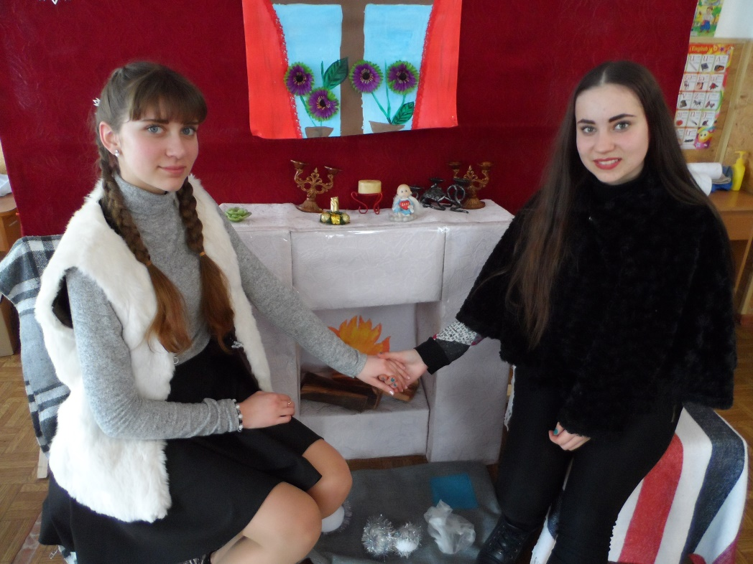

**Gerda:**Our Granny!

**Granny:** My dear children!

**Man:**Good evening, ma'am!

**Granny:**Good evening, sir! What can I do for you? Who are you?

**Man:**I'm the King's Counsellor! I want to buy the roses.

**Granny:**Do you like flowers?

**Man:** No, I hate them.

**Granny:**Why do you want to buy them then?

**Man:** I buy rarities. In winter flowers are rare! Here are ten pounds for your roses.

**Granny:** I am not going to sell the roses. We like them very much.

**Gerda:**Yes, we love them.

**Man:** Thirty pounds:

**Granny:**No!

**Man:** Fifty:

**Granny:**No!

**Man:**I'm the King's Counsellor! I'm very rich! I sell ice. I know the Snow Queen! I can buy anything!

**Granny:**They are not for sale.

**Man:**You are a crazy old woman!

**Kay:** Don't shout at our Granny! She is so kind!

**Man:** Well, I'm leaving! I'll take revenge! I'll tell the Snow Queen about you!

**Kay:**What an angry man!

**Gerda:**Granny, who is the Snow Queen?

(The sounds of mysterious music)

**Granny:** The Snow Queen lives in the North! She is very beautiful but very cruel!

(The sounds of the blizzard)

(The Snow Queen appears)

The Snow Queen: Have you seen the Mystic Queen

Riding in her limousine

Over hills and dales till morning.

If you like I'll take you there

Find some colours you can wear.

Colours that you've only seen while sleeping.

**Kay:**Oh! Who are you?

**S.Q.:**I am the Snow Queen. Good evening!

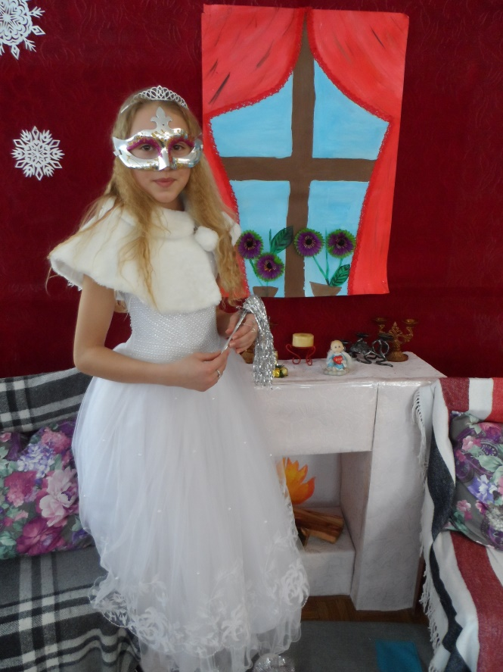

**Granny:**Good evening! Sit down, please!

**S.Q.:**No! It is very hot for me! You are very nice but old and poor. And you have two children. And I am very rich but alone. So, I'll take this boy from you!

**Kay:**What? Granny! I don't want to go with her!

**Gerda:**Granny! Don't give Kay to her!

**S.Q.:** Kay! You'll be my son! You will live in the beautiful palace!

**Kay:**I don't want!

(The Snow Queen touches Kay with her magic wand. The frightful music sounds.)

**Kay:** Ha-ha-ha! How fat and funny you are!

**Gerda:**What's the matter?

**Granny:**I don't recognize you!

**Kay:** I don't want to live in this poor house! I am leaving. Goodbye!

(He runs out)

**Scene 2**

**Gerda:** I am very tired! I have been looking for Kay for so long! But I must go on and find my brother!

(Gerda sings a sad song.)

**Lady Crow:**Caw! Caw! Caw! Good morning, young lady!

**Gerda:**Good morning!

**G. Crow:**Where are you going, young lady?

**Gerda:**I am looking for my brother Kay.

**G. &L. Crow:** Caw! Caw! Caw!

**G. Crow:**It's the name of our prince! Go with us and you'll see your brother!

**L. Crow:**Let's go!

**Gerda:** Oh, thank you very much.

(In the palace. Prince and princess are playing horses.)

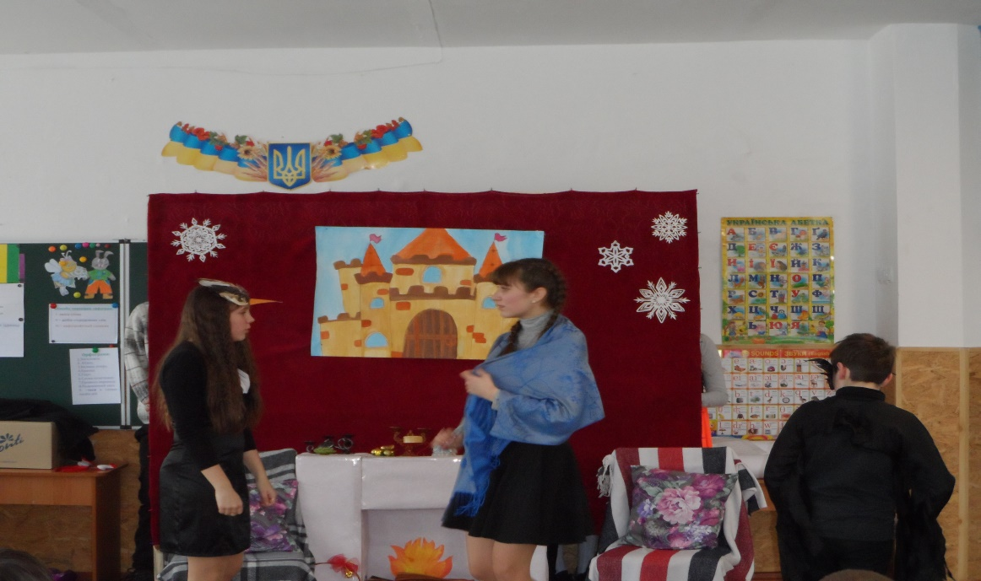

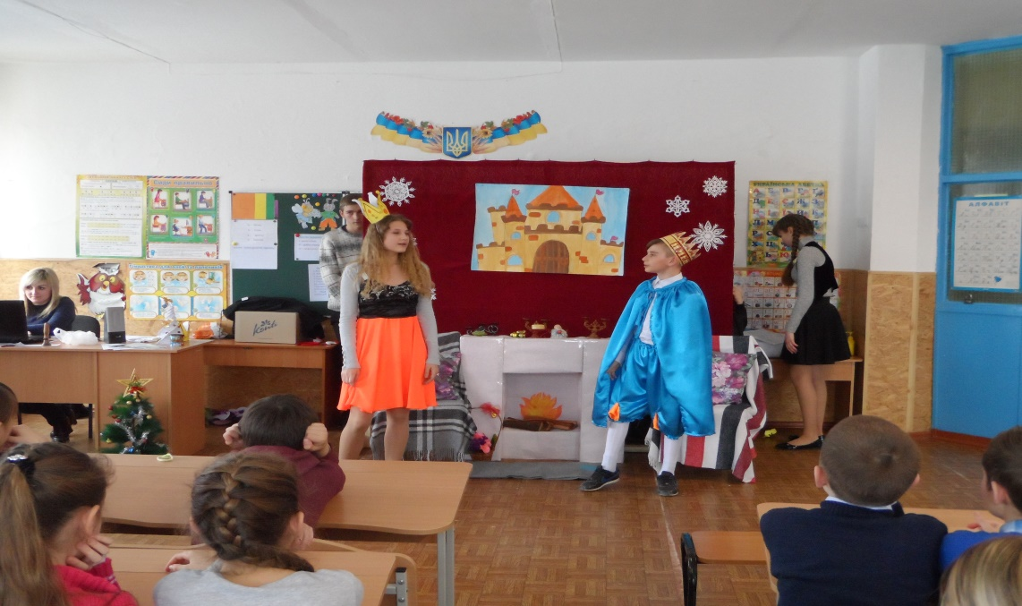

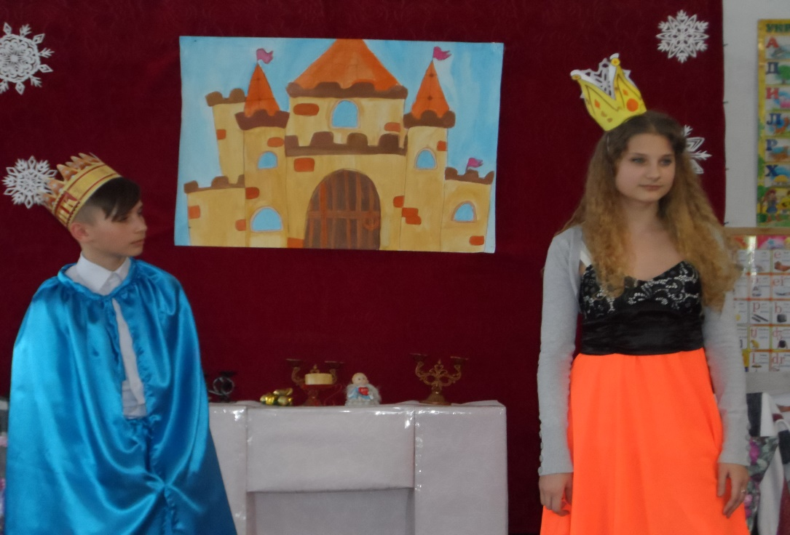

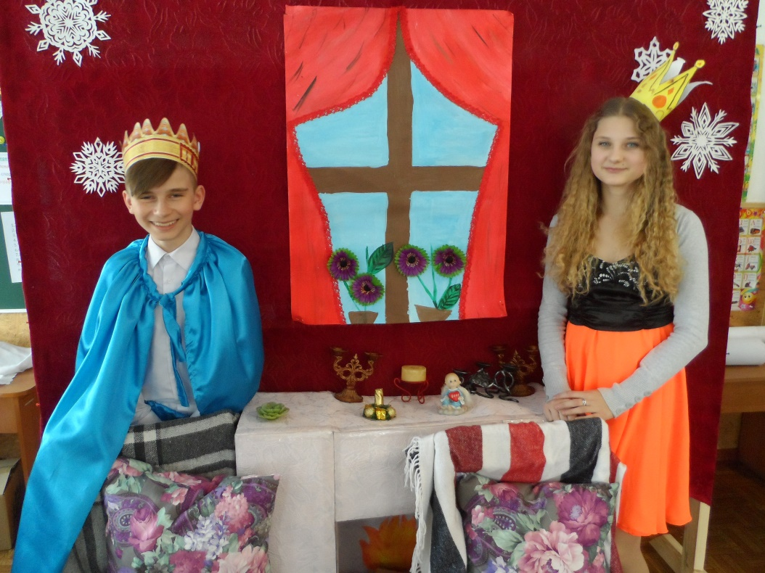

**Prince:** Stop playing this game, Elsa! I'm tired of being a horse. Let's play another game.

**Princess:**Let's play hide-and-seek!

**Prince:**OK. You hide and I'll count to twenty!

(Princess is running around the room. She sees Gerda and shrieks)

**Princess:**Who is there?

**Prince:**Is it a rat?

**Princess:** It's a girl and two crows.

**Prince:** What are you doing here, young lady? Why are you crying?

**Gerda:** I am Gerda. I'm crying because you are not my brother. He was carried by the Snow Queen! I thought he was here!

**Prince:**Don't cry! We'll help you! Where are you going?

**Gerda:**I'm going to the North. I must find the Snow Queen!

**Princess:** It's a long way!

**Prince:**We'll give you a carriage!

**Princess:**And I'll give you a coat, a muff and boots. Give my clothes to Gerda!

(Servants come and bring the clothes.)

**Gerda:**Thank you very much!

**Scene 3**

(The storyteller is sitting on the pillows in front of the fireplace.)

**Storyteller:**Everything is all right! Gerda is going in the carriage. The poor boy will be saved. Quite! What's there? Robbers!

(The robbers appear on the stage and perform the robbers' dance.)

(A camp of robbers in the forest. An old woman is near the fire. The robbers have brought Gerda.)

**Robber 1:**Look what we've got!

**Robber 2:**Here is a gold carriage!

**Robber 3:**And this is the girl from the carriage!

**Old Woman Robber:**How nice she is! I think she will be very tasty!

**Gerda:**Don't kill me, please! Let me go! 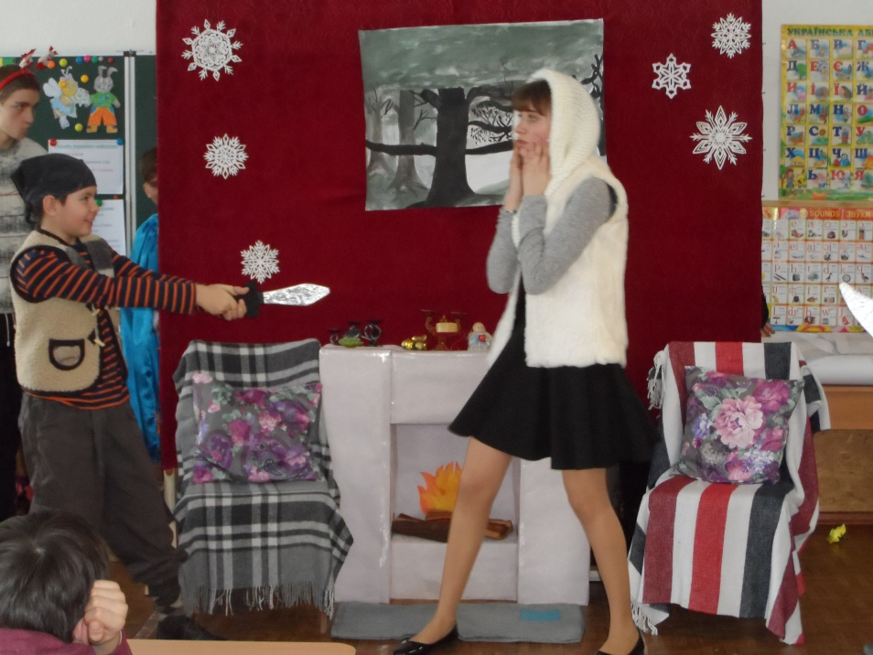

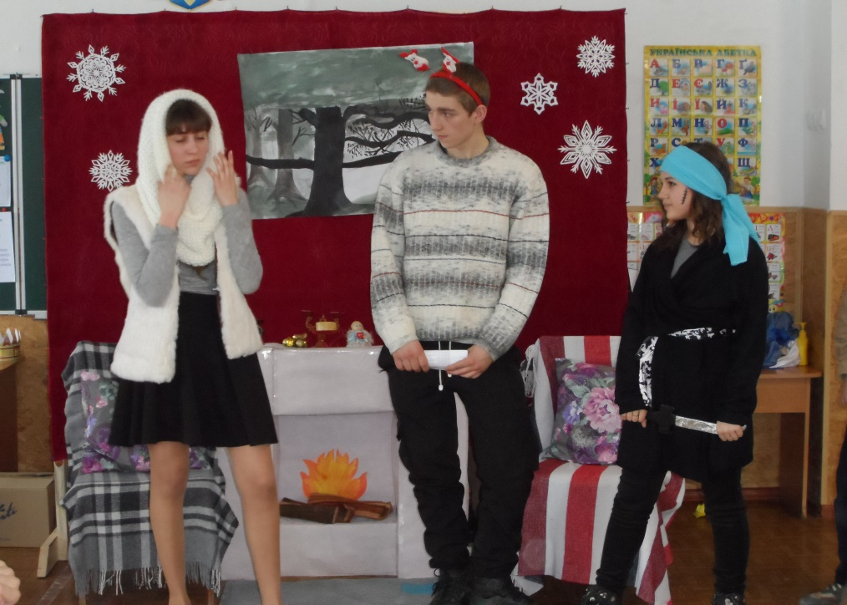

**Robber 4:**What a silly girl! Ha-ha-ha!

**Robber 5:**You'll be killed!

**Gerda:**Dear robbers! Please let me go! Kay will die without me!

**Old Woman Robber:**I'm going to eat you!

**Little Robber Girl:**Don't touch her! She will be mine! She will play with me! Give me your muff and your hat! What's your name?

**Gerda:** I'm Gerda. You can take my clothes but I'll be cold when I get to the Snow Queen.

**Little Girl Robber:**No! You won't go there! You will live with me! Look what I've got! Come, come here quickly!

(The Reindeer appears)

**Little Girl Robber:**Gerda, look how funny he is!

(She touches the reindeer with a knife.)

**Gerda:** Don't do it, please!

**Little Robber Girl:**Why? I like the way it trembles all over.

**Gerda:**May I ask him a question?

**Little Robber Girl:**Yes, you may.

**Gerda:**Tell me, deer! Did you live in the North?

**Reindeer:**Oh, yes!

**Gerda:**Have you ever seen the Snow Queen?

**Reindeer:**Yes, I have. Once she passed me! She had a little boy with her! He was white with cold. She called him Kay.

**Gerda:**He has seen her. He is my brother. Dear girl! Let me go! I must save Kay! He will die in the North.

**Reindeer:**Do let her go! I'll take Gerda to the Snow Queen's Kingdom.

**Little Girl Robber:**All right! There is nothing to be done. I won't give you your muff! I like it. Kiss me.

**Gerda:**Thank you, girl!

**Reindeer:**Thank you!

**Little Robber Girl:**Good luck, Gerda!

**Gerda:**Goodbye! Goodbye!

**Scene 4**

(The storyteller is sitting on the pillows in front of the fireplace.)

**Story-teller:**Oh, how sad I am! Poor Gerda! She is riding on the Reindeer. Help her to save Kay!

**Gerda:** Is this the kingdom of the Snow Queen?

**Reindeer:**Yes, it is. I can't go farther. You must remember, the Snow Queen is very cruel and it is very difficult to get into her palace!

**Gerda:** I must go there! Thank you, my dear friend!

(In the palace: Kay is on the icy throne.)

**Gerda:**Kay, Kay! Are you frozen? Answer me!

**Kay:**Hush, Gerda! You are bothering me!

**Gerda:** Dear Kay! It's me, Gerda! You didn't even say to me: "Glad to see you!"

**Kay:**Glad to see you.

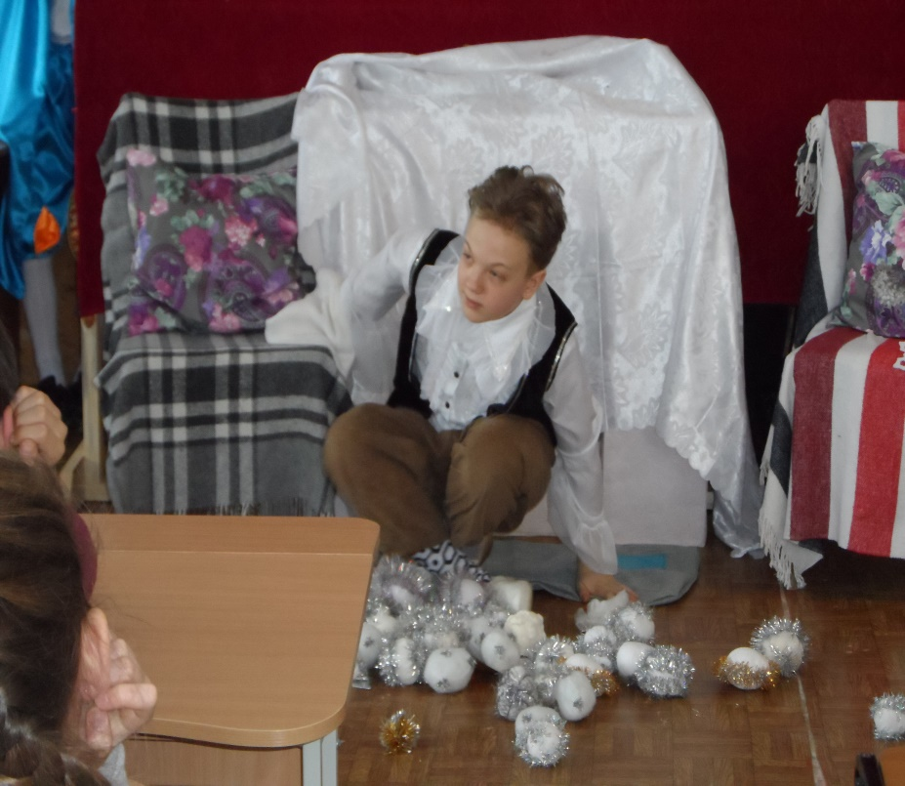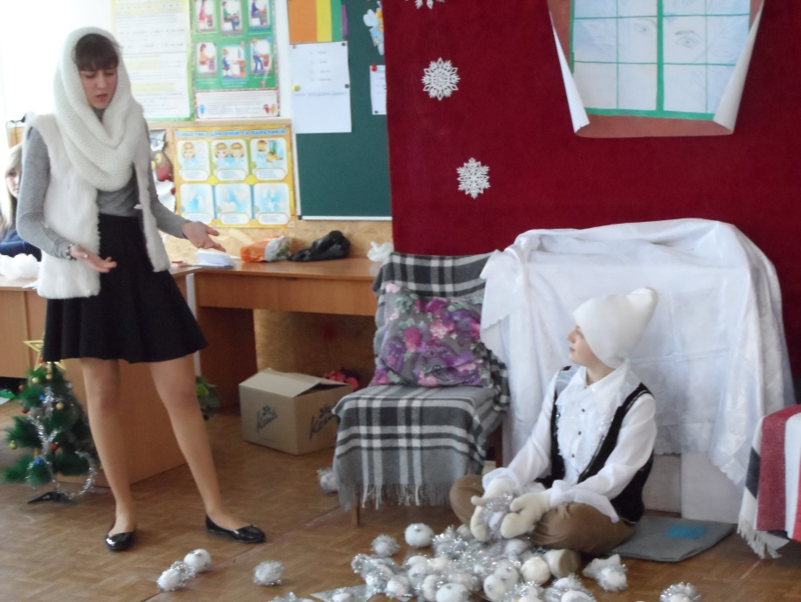

**Gerda:**You sound so cold. Are you really my brother?

**Kay:** I am really Kay. I am very busy. I must make the word out of icicles.

**Gerda:**Kay, let's go home. It's spring there. The sky is blue, the sun is shining, the birds are singing.

(She weeps and embraces Kay.)

**Kay:**I am cold, Gerda. Is it you? What's the matter? I can walk!

**Gerda:** Let's go! We will get home.

**Scene 5**

(The same room as in the first scene.)

**Little Robber Girl:**Can you hear? The stairs are creaking!

**Gentleman Crow:**They are coming!

**Little Robber Girl:**Granny, look, it's Gerda!

**Prince:**Look, it's Kay!

**Princess:**Granny, look, they are both here!

**G. &L. Crow:**Welcome home!

**Granny:**My dear children! You are back at last!

**Snow Queen:**You must give this boy back to me at once or I'll turn you into ice.

**Man:**I'll crack you into pieces.

**Gerda:**Nobody is afraid of you here!

**Snow Queen:**Oh, we'll see!

**Little Robber Girl:**You can wave your arms, your legs and your tail, but we won't give Kay to you!

**Kay:**Go away, you two! We are not afraid of you. Thank you, dear friends!

(Final song)

***The song "I love you, English*** *"*

*(під музику пісні "Беловежская Пуща ")*

*I began to learn you*

*Every minute and day*

*That is why I know now*

*Good expressions and words*

*How nice to learn you*

*How funny to speak*

*Make up interesting stories*

*and to read and to sing (2)*

*You, you, you*

*you, you, you*

*In the morning and day.*

*You, you, you*

*you, you, you*

*In the day and at night*

*You, you, you*

*you, you, you*

*Always are in my heart*

*English language-the nicest*

*Of all foreign languages!*

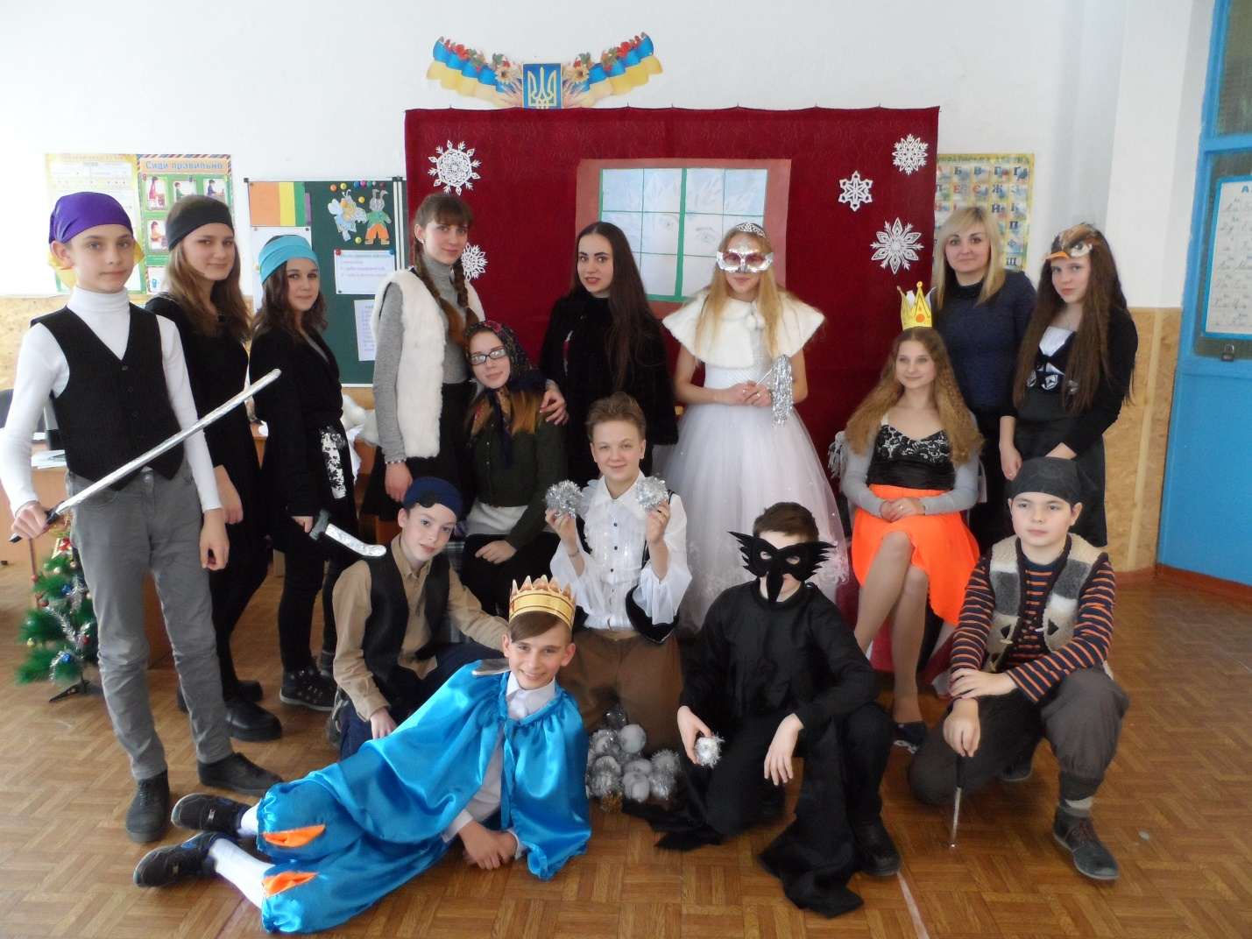

Використані джерела:

Електронний ресурс

http://xn--i1abbnckbmcl9fb.xn--p1ai/%D1%81%D1%82%D0%B0%D1%82%D1%8C%D0%B8/589138/