**План-конспект уроку**

**Тема:**Велика Британія

**Підтема**: Подорож до Лондону.

**Мета:**

* ***Навчальна:*** Поглибити знання учнів про визначні місця Лондона.Практикувати утворення часових граматичних форм.
* ***Освітня:*** Ознайомити з визначними місцями Лондона. Ознайомити з утворенням Neither I do, So I do.
* ***Розвиваюча:*** Розвивати навички говоріння, читання, аудіювання, письма.
* ***Виховна:*** Виховувати почуття поваги до пам'яток культури й потребу в пізнанні світової культури**.**

**Обладнання**: роздатковий матеріал, карта, глобус, комп’ютер.

**Тип уроку:** узагальнюючий

**Хід уроку:**

**І. Presentation**

**Warming up**

1. *Організаційний момент*

Good morning dear children. I am very glad to see you. Let's begin our English lesson. At the beginning we’ll revise the prepositions of place. Let’s do it with our poem “One day I’ll say: It’s me. I’ve come. Hello, London!”

**Teacher:** Dear children. Look at the blackboard. Look at these pictures. How do you think? What is our lesson about? (учні відповідають)

**Teacher:** Yes, you are right. It is about London. Our topic lesson today is « The travel to London».

2. *Уведення в іншомовне середовище*. Фонетична зарядка. Гра «Фонетичне лото».

**II*. Practice***

**T:** Look at this globe! We are going to London now.

-What we know about London?

(діти відповідають)

-How many parts does Great Britain consist of? What are they?

(діти відповідають)

* Diana and Liza want to go to UK. (Situation at Globe)

(учні розповідають про країни , які входять до складу UK)

**T:** How to get to London?

* We can fly by plane.
* We can go by ship.
* We can go by train.
* What should you do?

**P: -**Buy tickets. (Situation at pay office)

**T:** We are in London now. Here is our guide.

**Guide:** Перша зупинка - Tower Bridge. From Tower Bridge you can see the Tower of London. It is a museum now.

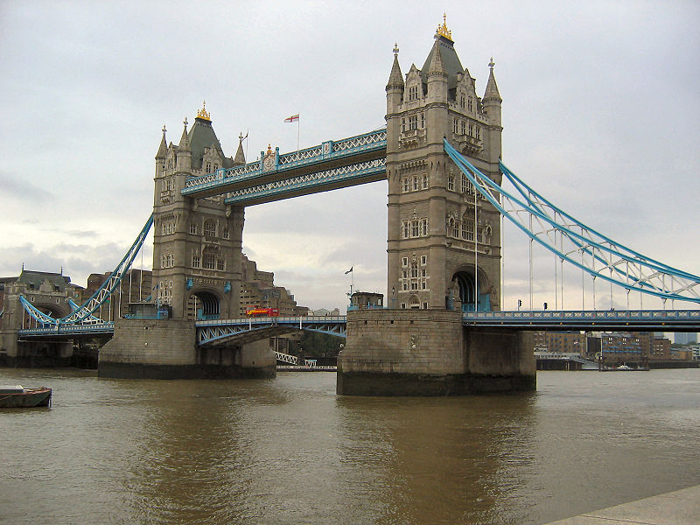

There are many beautiful sights in London.

Читання. **London**

London is the capital of Britain. It is one of the most interest­ing places in the world. About eight million people live here.

There is a big river in London – the Thames. There are a lot of bridges over the river. Tower Bridge is the most famous. It is more than 100 years old.

There are lots of places of interest in London. From Tower Bridge you can see the Tower of London. It is a museum now.

There are hundreds of interesting collections in it. There is a famous clock in London called Big Ben.

You can see splendid churches in the city. Westminster Abbey is one of the oldest royal churches. St. Paul’s Cathedral is the most wonderful classical church in Britain.

London’s parks and gardens are really beautiful. In Regent’s Park there is the Zoo. It is one of the biggest and most famous zoos in the world.

There are about 10 thousand streets in London with a lot of shops and cafes, cinemas and theatres, galleries and museums. Big red buses run up and down the streets. The oldest metro in the world, called Tube [tju:b], is here in London, too.

**Guide: Друга зупинка**. Big Ben. There is a famous clock in London called Big Ben.

**T: And now let’s do some exercise about the text. Tell me please are the following statements true or false? Agree with me if I am right. Say: "You are right" or "You aren't right" if the statement is false.**

1. London is a capital city.

2. The population of London is about eight thousand people.

3. Tower Bridge crosses the river Thames.

4. Tower of London is a church.

5. Big Ben is a clock.

6. One of the oldest royal churches is Westminster Abbey.

7. There is only one park in London — Regent’s Park.

8. Tube is the oldest metro in the world.

**Guide: Третя зупинка -** Westminster Abbey ***-*** Westminster Abbey is one of the oldest royal churches.

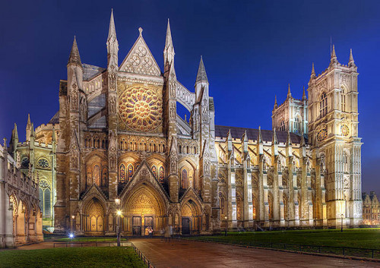

**Guide: Четверта зупинка.** Tower of London.

From Tower Bridge you can see the Tower of London. It is an ancient fortress, a famous prison. It was built 900 years ago. But now it is a museum. There are hundreds of interesting collections in it.

**Guide:** Look, **this is a souvenir shop!**

Let**’**s buy souvenirs! (Situation atsouvenir shop)

**ІІІ. A lesson summary**

**Teacher: Good job. It was very interesting information*.***

**Teacher: *Are there any churches in London?***

**P:** We can see splendidchurches in the city. Westminster Abbey is one of the oldest royal churches. St Paul’s Cathedral is the most wonderful classical church in Britain and it is the second large church in Europe.

**Teacher: *What about Big Ben?***

**P:** There is a famous clock in London called Big Ben. Big Ben is the name of the clock and the bell. The bell weights 13 tons.

**IV. Homework**

Page 132, ex.7

**Гожулівський навчально-виховний комплекс**

**Полтавської районної ради**

**Урок англійської мови у 7 класі**

**« Подорож до Лондону»**

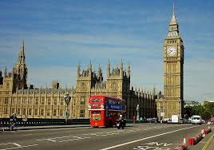

**Підготувала і провела**

**вчитель англійської мови Гожулівського НВК**

***Джуган Інна Леонідівна***

**Гожули 2018**